 Start-Work Checks | Confined Space Entry

Start Work Authority: Confirm below are in place and verified prior to starting work
Save Your Life Actions  All exposed person(s) performing work must confirm each of the action items below |  |  |  | Person(s) Performing Work (initial) | Start-Work  Verifier  (initial) | 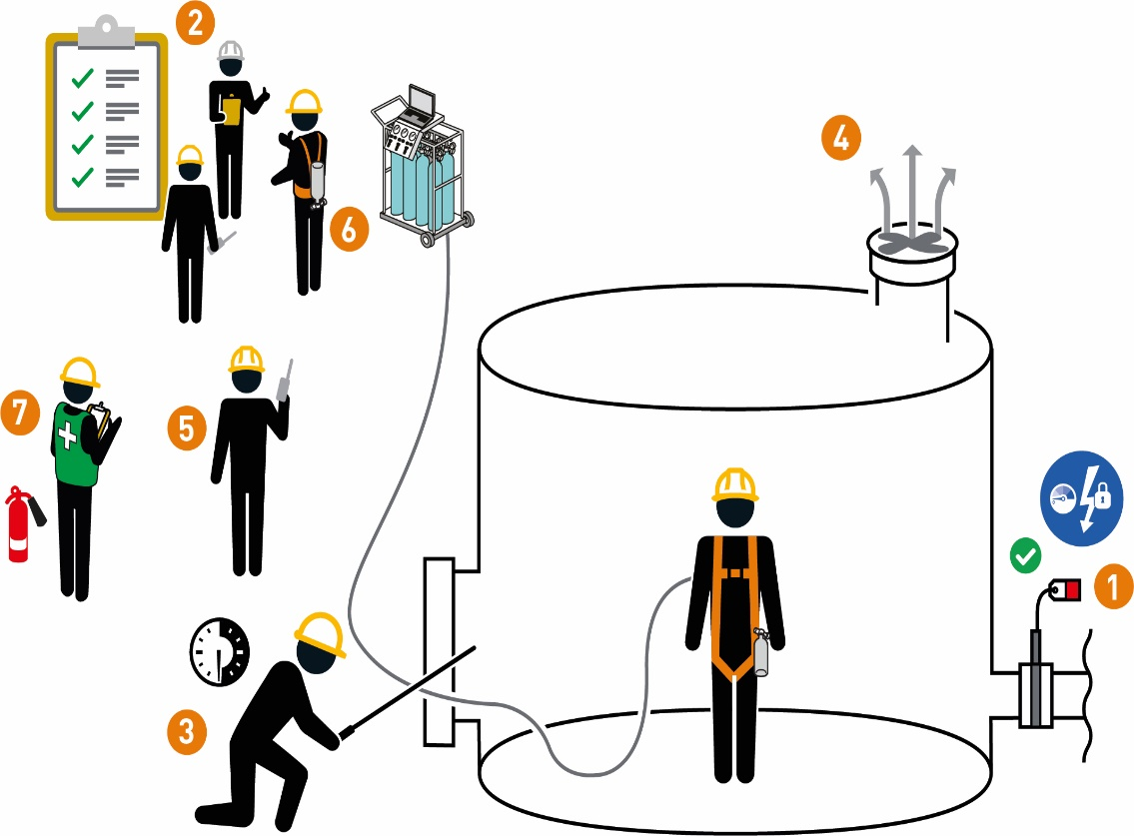
Energy Isolation
I have confirmed:
1 | The confined space has been evaluated for energy isolation requirements.  Does Confined Space Entry work require energy isolation?  Yes: No:  If yes: Complete Energy Isolation Start-Work Check.  If no: Continue to Step 2.
Prior to Confined Space Entry
I have confirmed:
2 | The hazards have been identified, controlled and it is safe to start.
3 | Gas testing frequency has been established.
4 | Ventilation is in place and working.
5 | An attendant is in place and the method of communication is agreed to and tested prior to entry.
6 | My breathing apparatus is in good working condition.  If no breathing apparatus is required: Continue to the next step.
7 | The rescue plan is in place and ready to be used.

Stop and seek help if any of the above controls/safeguards are not in place
Role |  | Printed Name | Date
Start -Work Verifier

Save Your Life Actions | Confined Space Entry

Start Work Authority: I will not start work until I confirm…
Actions |  | How to (examples)
Energy Isolation
1 | The confined space has been evaluated for energy isolation requirements.  Does Confined Space Entry work require energy isolation?  Yes: No:  If yes: Complete Energy Isolation Start-Work Check.  If no: Continue to Step 2. | • All potential energy sources have been identified, isolated and locked and tagged per isolation plan.  • The system has been drained, flushed, or purged to remove explosive materials or gases.
Prior to Confined Space Entry
2 | The hazards have been identified, controlled and it is safe to start. | - • Complete a task risk assessment specific to the scope of work  - • Discuss hazards with the work team prior to the start of work  • Check for simultaneous operations that may introduce an additional hazards
3 | Gas testing frequency has been established. | • Gas testing is being done by a Qualified Gas Tester  • Initial gas testing and the required follow up testing frequency before starting work.  • Check testing results and agree on a schedule for follow-up testing before starting work
4 | Ventilation is in place and working. | • Confined space is continuously ventilated  • If using mechanical ventilation:  • The flexible ducting is arranged so there is continuous air flow in the entire space.  • Equipment is bonded and grounded to prevent static electricity hazards.  • Ventilation inlets:  • are not near an ignition source.  • will not be affected by wind/weather conditions and will not have flow restrictions.  • will not draw contaminated air into the space (e.g., vehicle, generator exhaust).
5 | An attendant is in place and the method of communication is agreed to and tested prior to entry. | • Dedicated attendant is present at the designated entry point(s) to the confined space.  • Ask the attendant to describe their responsibilities, which include:  • Using previously agreed upon communication methods (e.g., hand signals, radio)  • Monitoring personnel in the confined space  • Documenting entry and exits from the confined space  • Monitoring the confined space for changing conditions  • Initiating the emergency rescue response if needed
6 | My breathing apparatus is in good working condition.  If no breathing apparatus is required: Continue to the next step. | • The breathing apparatus is complete, certified, in good working condition  • The main air supply is correct and properly connected before using it.  • Escape pack is in place and functioning prior to entry.
7 | The rescue plan is in place and ready to be used. | - •Discuss method of communication with attendant & rescue team prior to entry.  - •Rescue equipment is at the job site  - •The entrant is wearing rescue equipment per plan (e.g., harnesses, retrieval device).  - • The rescue crew:  - • is available  - • is aware of specific hazards related to this task  • can execute the rescue plan

