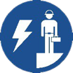 Start-Work Checks | De-Isolation and Re-Energising

Start Work Authority: Confirm below are in place and verified prior to starting work
Save Your Life Actions  All exposed person(s) performing work must confirm each of the action items below |  |  |  | Person(s) Performing Work (initial) | Start-Work  Verifier  (initial) | 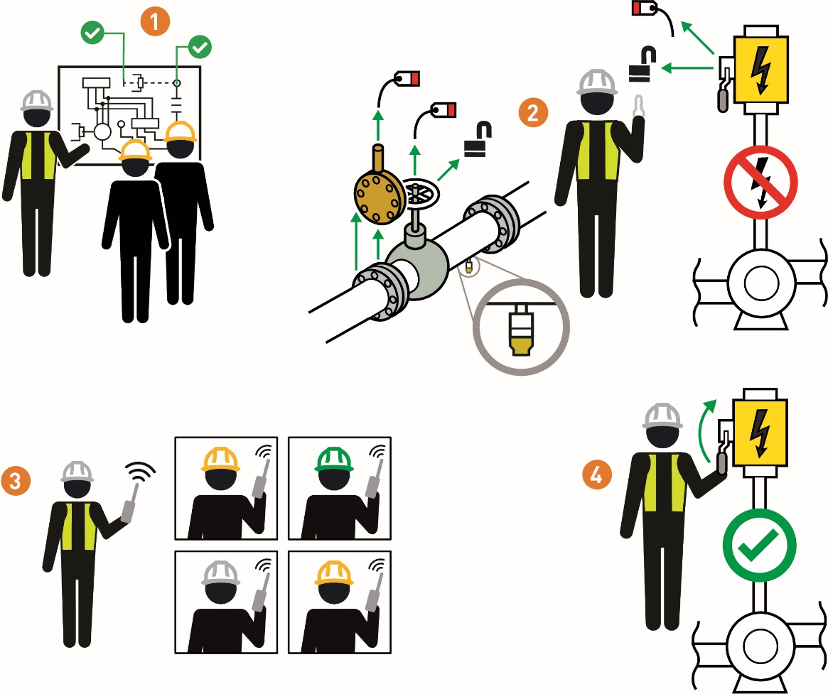
I have confirmed:
1 | Circuit, system, and/or equipment to be de-isolated/re-energized is the one identified in the isolation plan or drawing.
2 | Isolation devices are removed per the isolation plan or drawing.
3 | Any personnel affected by the re-energizing activity have been notified.
4 | The circuit, system, and/or equipment has been re-energized per plan or drawing.

Stop and seek help if any of the above controls/safeguards are not in place
Role |  | Printed Name | Date
Start -Work Verifier

Save Your Life Actions | De-Isolation and Re-Energising

Start Work Authority: I will not start work until I confirm…
Actions |  | How to (examples)
1 | Circuit, system, and/or equipment to be de-isolated/re-energized is the one identified in the isolation plan or drawing. | • Tags or markings identify the circuit, system and/or equipment to be de-isolated/re-energized.  Note: Confirm circuit, system, and/or equipment is ready to be de-isolated and re-energized (e.g. all work has been completed)
2 | Isolation devices are removed per the isolation plan or drawing. | • Physically inspect:  • Work area to confirm all mechanical, process and electrical isolations were removed per plan.  • Bleed and vent points to confirm they are closed/open per plan or procedure.
3 | Any personnel affected by the re-energizing activity have been notified. | • Personnel in/near the work area or affected by the re-energizing of circuit, system, and/or equipment are aware it is ready to be put back in service.  • Personnel are not in the Line of Fire of re-energized potential hazardous energy sources (e.g., electrical, pressure, hydraulic, mechanical etc)
4 | The circuit, system, and/or equipment has been re-energized per plan or drawing. | • Circuit, system, and/or equipment has been re-energized per the isolation plan or system/equipment operating procedure.

