 Start-Work Checks | Decommissioning & Demolition

Start Work Authority: Confirm below are in place and verified prior to starting work
Save Your Life Actions  All exposed person(s) performing work must confirm each action below |  |  |  | Person(s) Performing Work (initial) | Start-Work  Verifier  (initial) | 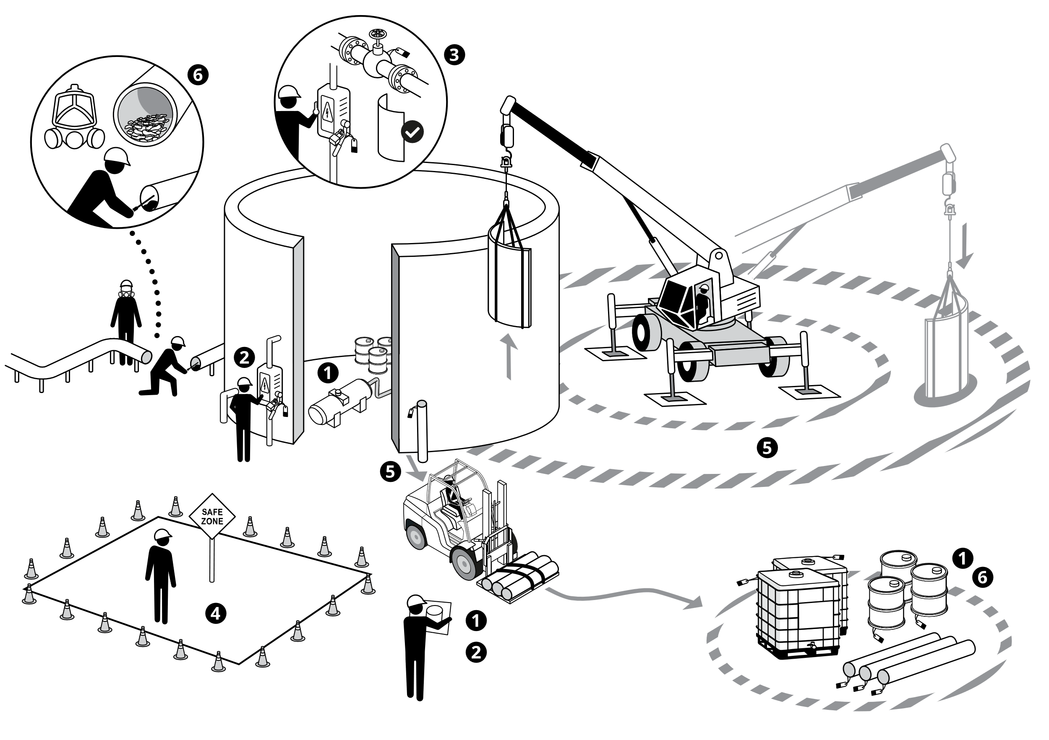
I have confirmed:
1 | Equipment to be demolished is emptied/cleared of hazardous materials.
2 | All energy sources are identified, isolated and marked / colour coded.
3 | Equipment that may have stored energy is identified and marked.
4 | Safe areas, out of the line of fire are identified, with barriers in place where practical.
5 | Work area is assessed for potential dropped or unsecure objects, and potential objects have been removed or secured.
6 | Residual contaminants have been identified, and appropriate PPE and work methods provided.

Stop and seek help if any of the above safeguards are not in place
Role |  | Printed Name | Date
Start -Work Verifier

Start-Work Checks | Decommissioning & Demolition

Start Work Authority: I will not start work until I confirm…
Actions |  | How to (examples)
1 | Equipment to be demolished is emptied/cleared of hazardous materials. | (e.g. hydrocarbons, chemicals, contaminants, NORM, etc.).
2 | All energy sources are identified, isolated and marked / colour coded. | (e.g. electrical, pressure, gravity, etc.)
3 | (e.g. spring-loaded equipment, bent or obstructed materials, valves, pipe, suspensions, loading arms) | (e.g. spring-loaded equipment, bent or obstructed materials, valves, pipe, suspensions, loading arms)
4 | Safe areas, out of the line of fire are identified, with barriers in place where practical. | unforeseen equipment, materials movement
5 | Work area is assessed for potential dropped or unsecure objects, and potential objects have been removed or secured. | objects that may become loose / unsecure during the demolition process and have the potential to cause harm.
6 | Residual contaminants have been identified, and appropriate PPE and work methods provided. | (e.g. Lead, Asbestos, PCB's, etc.)

