 Start-Work Checks | Driving

Start Work Authority: Confirm below are in place and verified prior to starting work
Save Your Life Actions  All exposed person(s) performing work must confirm each of the action items below |  |  |  | Person(s) Performing Work (initial) | Start-Work  Verifier  (initial) | 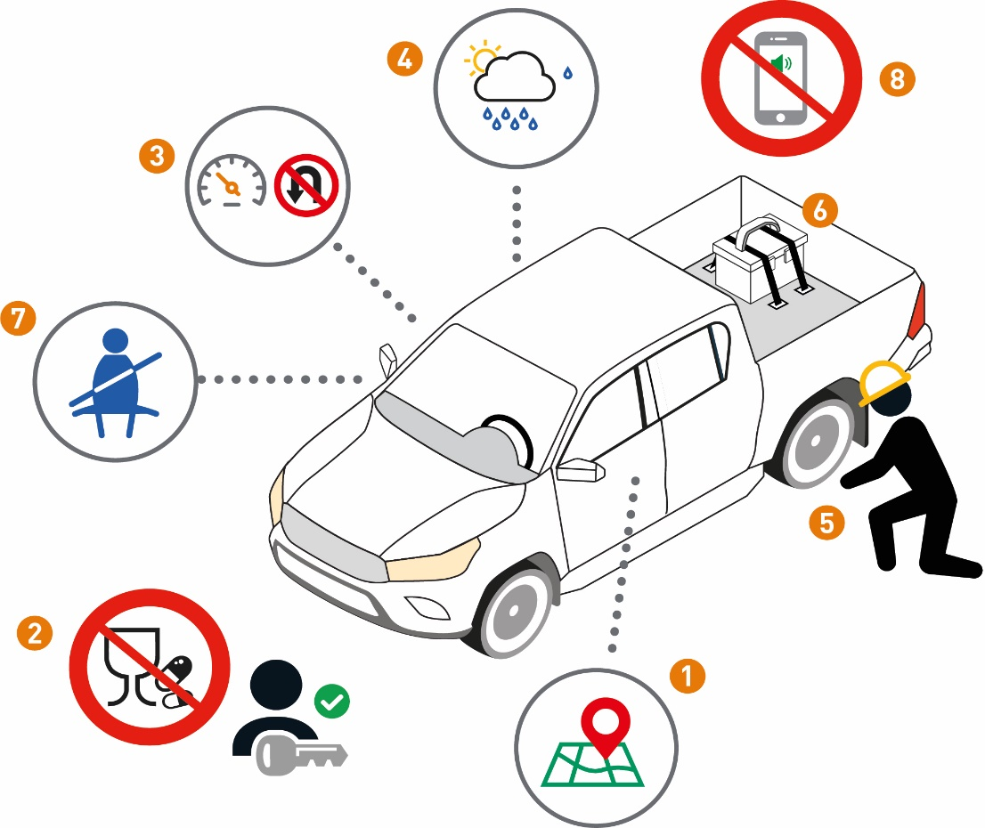
I have confirmed:
1 | A plan is in place to manage the journey hazards.
2 | The driver is fit, rested and fully alert
3 | The driver is familiar with local road and driving regulations.
4 | The driver is aware of anticipated road hazards and weather conditions.
5 | A pre-trip walk around inspection has been completed to confirm the selected vehicle is fit for the journey.
6 | The objects inside and outside the vehicle have been secured prior to the trip.
7 | All vehicle occupants are using their seatbelts.
8 | A plan in place to eliminate or minimize distractions while driving.

Stop and seek help if any of the above controls/safeguards are not in place
Role |  | Printed Name | Date
Start -Work Verifier

Start-Work Checks | Driving
Start Work Authority: I will not start work until I confirm…
Actions |  | How to (examples)
1 | A plan is in place to manage the journey hazards. | • Journey Management Plan includes, and the driver is aware of:  • the destination  • route to be taken  • local traffic  • weather, and road conditions  • designated emergency contacts  • The driver is authorized and has applicable license to operate vehicle type in geographic area.  • The driver has allocated time in the journey schedule for rest breaks.  • If the vehicle is equipped with a monitoring system, the system is activated during the journey.
2 | The driver is fit, rested and fully alert | • The Driver is:  • being well-rested  • fit to undertake the journey  • not under the influence of drugs or alcohol or medications that may impair ability to drive  • Controls are in place to manage personal fatigue include:  • maximum drive times  • minimum hours of rest prior to drive  • If applicable, rest breaks during the journey
3 | The driver is familiar with local road and driving regulations. | • The driver is familiar with speed limits, local signage and general communications (e.g., radio usage if applicable and channels).
4 | The driver is aware of anticipated road hazards and weather conditions. | • The driver has checked weather forecasts, local traffic and driving environment (e.g., ice, snow, rain, flooding) and confirmed road conditions (e.g., pavement, gravel, road construction).
5 | A pre-trip walk around inspection has been completed to confirm the selected vehicle is fit for the journey. | • Pre-trip inspection is complete prior to vehicle use.  • The vehicle is:  • in good working order  • specific for the journey  • equipped for anticipated weather, road conditions, and emergencies.  • Perform a 360⁰ walk around to ensure the vehicle is free from hazards prior to movement.
6 | The objects inside and outside the vehicle have been secured prior to the trip. | • Safety or restraint systems are in place and capable of securing the load.  • Tools, equipment and other loose objects are removed or secured both inside and outside the vehicle (e.g. tool-boxes, cargo nets)  • If applicable, a load securement checklist is completed
7 | All vehicle occupants are using their seatbelts. | • Seatbelts are in good working order and are being worn properly (e.g., three-point restraint).
8 | A plan in place to eliminate or minimize distractions while driving. | • The driver will not interact with a phone or operate a device while driving.  • Incoming calls are to be diverted while driving.  • The driver will stop in a safe area to interact with any phone or mobile devices  • Digital mapping device (e.g., GPS/mapping/directional guidance) is programmed prior to the journey.

