
Start-Work Checks | Excavation

Start Work Authority: Confirm below are in place and verified prior to starting work
Save Your Life Actions  All exposed person(s) performing work must confirm each of the action items below |  |  |  | Person(s) Performing Work (initial) | Start-Work  Verifier  (initial) | 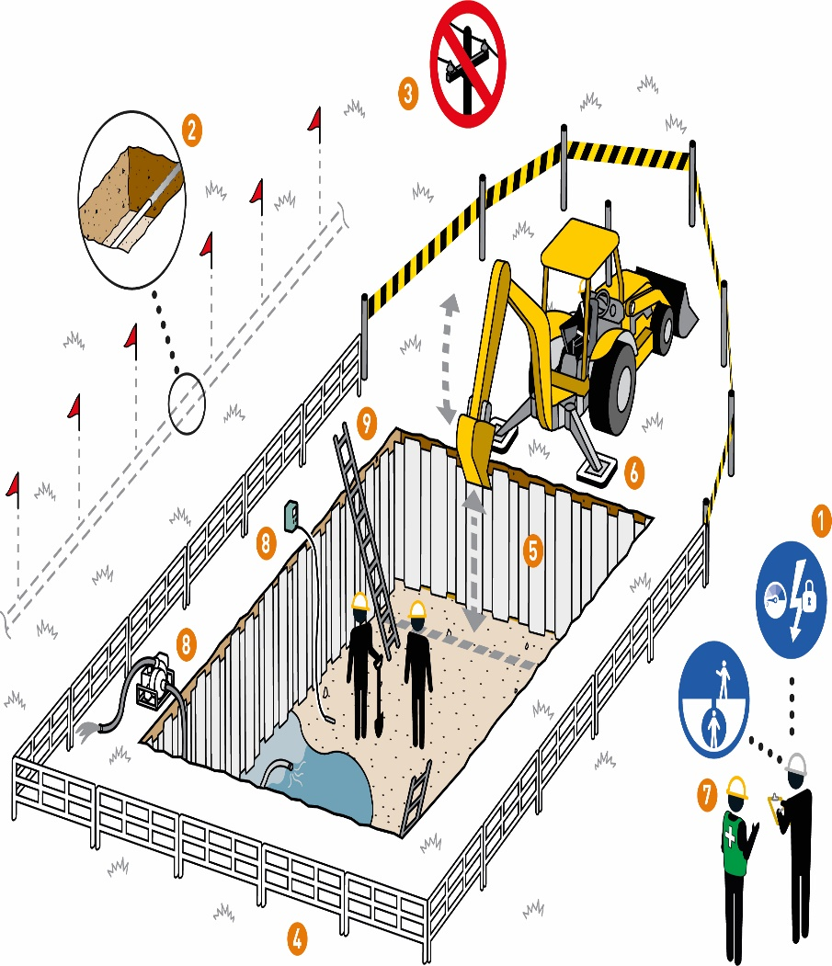
Energy Isolation
I have confirmed:
1 | Excavation has been evaluated for energy isolation requirements.  Does Excavation work require energy isolation? Yes: No:  If yes: Complete Energy Isolation Start-Work Check.  If no: Continue to Step 2.
Prior to Excavation activities
I have confirmed:
2 | Underground utilities are visibly marked (e.g., pipelines, cables, communications, power).
3 | Excavation equipment maintains minimum clearances from overhead obstructions
4 | Excavation area is secured, and barriers are in place to prevent unauthorised access.
5 | Soil stability has been assessed and controls/safeguards are in place per excavation plan.
6 | Equipment stability and potential for unplanned movement have been assessed.
Hold Point: Continue if personnel enter excavation
7 | Excavation has been evaluated to determine if it is a confined space.  Is Excavation a Confined Space? □Yes  No  If yes: Complete Confined Space Entry Start-Work Checks.  If no: Continue to Step 8
8 | A plan is in place to protect personnel entering the excavation from:  -Cave in.  -Hazardous atmosphere; and  -Water accumulation.
9 | Excavations deeper than 1.2 m (4 feet) have access and egress.

Stop and seek help if any of the above controls/safeguards are not in place
Role |  | Printed Name | Date
Start -Work Verifier

Save Your Life Actions | Excavation

Start Work Authority: I will not start work until I confirm…
Actions |  | How to (examples)
Energy Isolation
1 | The excavation has been evaluated for energy isolation requirements.  Does Excavation work require energy isolation?  Yes: No:  If yes: Complete Energy Isolation Start-Work Check.  If no: Continue to Step 2. | • All potential energy sources have been identified, isolated and locked and tagged per isolation plan.  • The underground utility has been drained, flushed, or purged to remove explosive materials or gases.
Prior to Excavation activities
2 | Underground utilities are visibly marked (e.g., pipelines, cables, communications, power). | • Local utilities have been consulted about the dig so they can identify their lines (use programmes like Dial Before You  Dig (UK) or Call 811 (US))  • Underground utilities are visibly identified with flagging or paint  • Depth and width of utilities or structures are known before digging  • Before starting mechanical excavation, actions have been taken to locate and expose underground line/utility and  structures (e.g., probing, hand digging, soft digging, air knifing, hydro-vac)
3 | Excavation equipment maintains minimum clearances from overhead obstructions. | - • The exact location, height and voltage of overhead power lines have been identified.  • Maintain identified minimum distance between equipment and energy source  • To help with this, use flagging or barries on overhead power lines
4 | Excavation area is secured and barriers are in place to prevent unauthorised access. | • Excavation area is visibly identified with caution tape, silt fencing or other visual identification.  • Excavation area is secure from unauthorised access.  • No personnel are in line-of-fire hazards (e.g., swing radius of excavator, discharge side of trencher).  • Only essential personnel/crew are in the area where the excavation work is occurring.
5 | Soil stability has been assessed and controls/safeguards are in place per excavation plan. | • A competent person assessed the soil type to define the excavation safeguards.  • Excavations have a protective system (sloping, shoring, or shielding) in place as applicable  • Storage of excavated material is at least 0.61 m (2 ft) from the edge of excavation  • Ensure stability of adjacent utilities/structures potentially affected by excavation through means of shoring, bracing, and underpinning
6 | Equipment stability and potential for unplanned movement have been assessed. | • Equipment, load and ground surface have been assessed for stability.  •Verify:  • load securing  • workplace conditions/travel path  • equipment capacity  • Equipment maintains safe distance from the unprotected edges of excavation or trenches to prevent cave ins
Hold Point: Continue if personnel enter excavation
7 | The excavation has been evaluated to determine if it is a confined space.  Is Excavation a Confined Space?  Yes: No:  If yes: Complete Confined Space Entry Start-Work Checks.  If no: Continue to Step 8. | • The excavation has been evaluated to determine if it is a confined space (trench depths greater than or equal to 4 ft (1.2 m) with vertical walls and limited access/egress).  • If the excavation is a confined space follow the organization/company's confined space guidance, local regulations and complete the Confined Space Entry Start-Work Check.
8 | A plan is in place to protect personnel entering the excavation from:  -Cave in;  -Hazardous atmosphere; and  -Water accumulation. | • Excavation inspected by the competent person prior to entry, and as conditions change  • Protective systems are in place and may include:  • bracing  • shoring  • underpinning  • benching  • Retaining devices or shield systems in place.  • Daily inspection are performed to identify hazards and changing conditions.  • Initial gas testing is conducted by a Qualified Gas Tester  • Required follow up testing frequency is established per the plan  • Crew will conduct daily inspection to identify hazards and changing conditions (e.g. contamination, water build up or utilities encountered).
9 | Excavations deeper than 1.2 meters (4 feet) have access and egress. | • There is a safe means of access and egress when entering an excavation greater than 1.2 meters (4 feet) in depth, up to 6.7 m (25 ft) of lateral travel.  Examples are:  • ladder  • stairways  • ramps  • sloping for ingress/egress.

