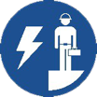 Start-Work Checks | Man-riding

Start Work Authority: Confirm below are in place and verified prior to starting work
Save Your Life Actions  All exposed person(s) performing work must confirm each of the action items below |  |  |  | Person(s) Performing Work (initial) | Start-Work  Verifier  (initial) | 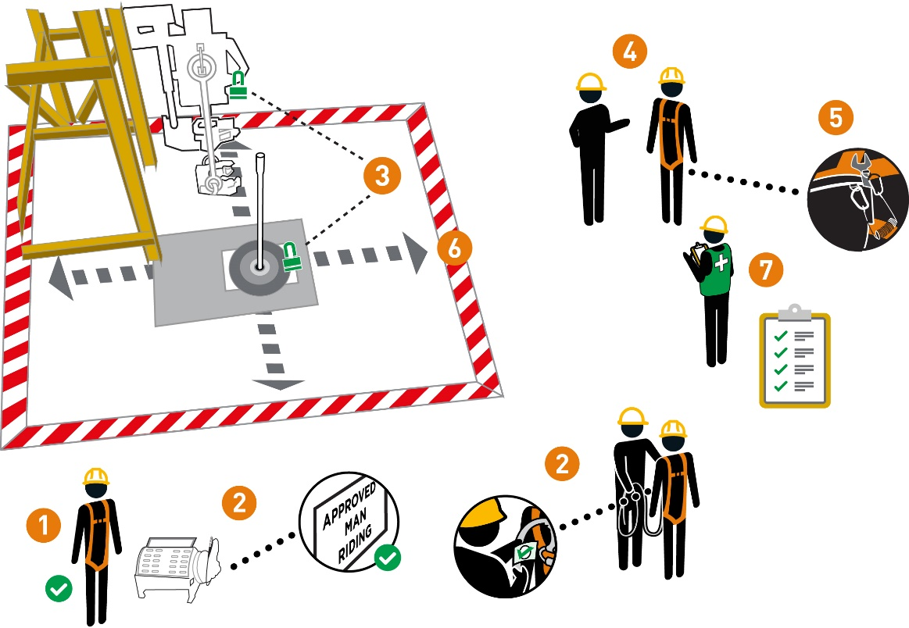
I have confirmed:
1 | Personnel involved with the man-riding operations are qualified to perform their task
2 | The man-riding equipment is:  • certified  • inspected  • rated for the task.
3 | All rotating or moving equipment close to man-riding activities are secured to prevent unplanned movement
4 | Communication methods have been agreed to by the workers
5 | The tools/materials being used at height are secured
6 | Barriers and drop/ exclusion zones are in place
7 | Rescue plan is in place and is ready to be used

Stop and seek help if any of the above controls/safeguards are not in place
Role |  | Printed Name | Date
Start -Work Verifier

Save Your Life Actions | Man-riding

Start Work Authority: I will not start work until I confirm…
Actions |  | How to (examples)
1 | Personnel involved with the manriding operations are qualified to perform their task | • Rider, Winch operator, and Spotter have all been trained and can describe their responsibilities
2 | The man-riding equipment is:  • certified  • inspected  • rated for the task. | • Winch: Certified “Suitable” for Man-riding  • Rigging equipment including cable inspected for wear/defects  • Harness: Inspected per work at heights requirements  • Fall arrest gear (if used): inspected
3 | All rotating or moving equipment close to man-riding activities are secured to prevent unplanned movement | • Hoisting and rotating equipment in the immediate area and at different levels are not moving (e.g., set the brake for the traveling block, lock out tag out)
4 | Communication methods have been agreed to by the workers | • Communication methods agreed to and tested for movement of rider (i.e., hand signals and radios)  • Confirm a common set of signals are used by the work crew
5 | The tools/materials being used at height are secured | • Tools used at heights have securing wire/lanyards/tethers  • Materials used at height are secured in storage boxes, pouches, bags etc.  • Cover openings to lower levels (e.g., grating, gaps etc.) or use debris nets  Note: Follow the site/company dropped object prevention program (e.g., Work at Height tool register)
6 | Barriers and drop/ exclusion zones are in place | • Establish drop/exclusion zones  • Control access to drop/exclusion zones during work at height (e.g. attendant or physical barriers)
7 | Rescue plan is in place and is ready to be used | • Confirm the work crew has discussed the rescue plan, including:  • How to start the rescue response  • Location of rescue equipment and responders  • Confirm the rescue crew:  • is available  • is aware of specific hazards related to this task  • can execute the rescue plan

