
Start-Work Checks | Mechanical Lifting

Start Work Authority: Confirm below are in place and verified prior to starting work
Save Your Life Actions  All exposed persons performing work must confirm each of the action items below |  |  |  | Person(s) Performing Work (initial) | Start-Work  Verifier  (initial) | 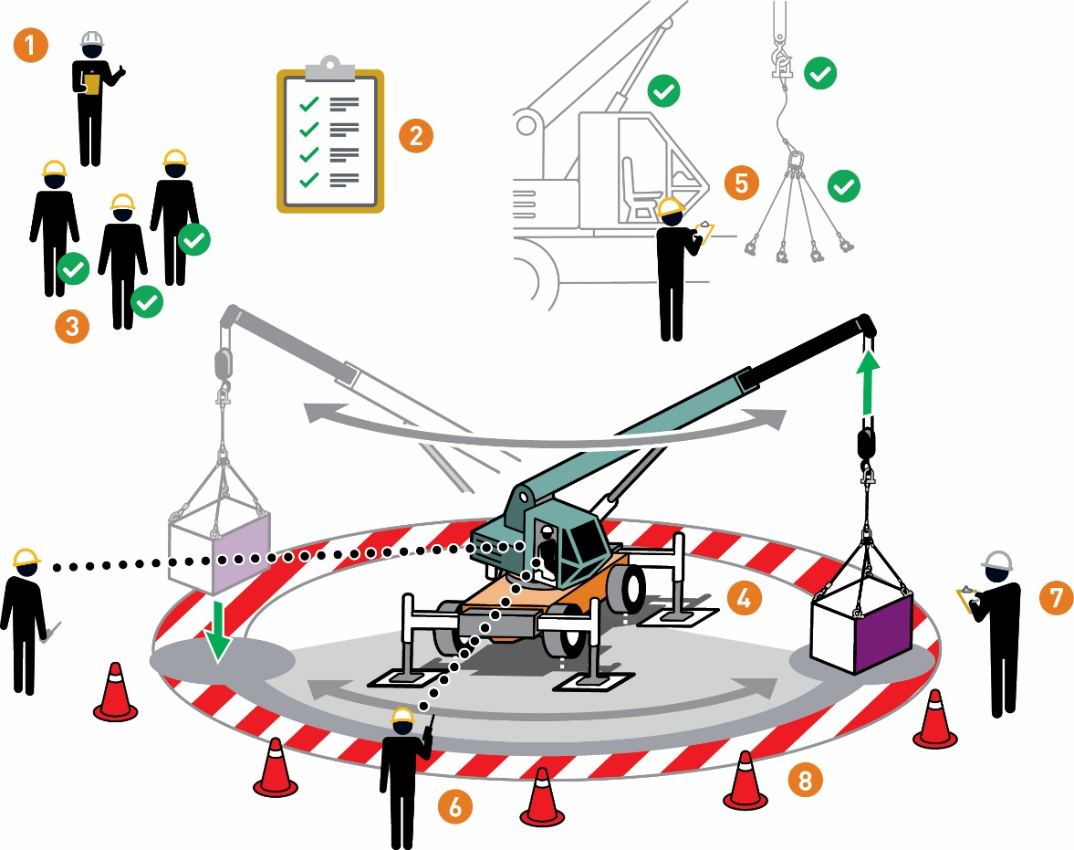
I have confirmed:
1 | The lift has been planned.
2 | The hazards are identified and controlled.
3 | Workers involved with the lift are qualified to perform their task.
4 | The lifting equipment is stable and potential for unplanned movement has been assessed.
5 | The lifting and rigging equipment is:  • certified  • inspected  • rated for the lift
6 | A communication plan and responsibilities are agreed to by the lift crew.
7 | The load has been inspected prior to lift.
8 | Barriers and exclusion zones are in place.

Stop and seek help if any of the above controls/safeguards are not in place
Role |  | Printed Name | Date
Start -Work Verifier


Save Your Life Actions | Mechanical Lifting

Start Work Authority: I will not start work until I confirm…
Actions |  | How to (examples)
1 | The lift has been planned. | • The lift method, equipment and number of people required has been assessed and determined.  • When required, an approved lift plan or procedure is in place and has been evaluated by a competent person.  • The lift has been assessed for:  •load weight  • load size  • centre of gravity (e.g., lifting points)  • The lifting equipment's current capacity and condition has been assessed  • Equipment operator and lifting crew have discussed the written lift plan prior to making a lift.
2 | The hazards are identified and controlled. | • Complete a task risk assessment specific to the scope of work  • Discuss hazards with the work team prior to the start of work  • Identify overhead hazards and/or other obstructions (e.g., overhead power lines), making sure to check:  •load path  •swing radius  •overhead hazards  •pickup/lay-down zones  • Check for simultaneous operations that may introduce any additional hazards.  • Discuss stop work considerations if work situation changes including change of weather  Note: Consider how to apply "hands free lifting" (e.g. use of push poles and/or taglines)
3 | Workers involved with the lift are qualified to perform their task. | • Lifting equipment operator and lifting crew are qualified to perform their task.  Note: To be "qualified" may require certification and/or assessment to meet company or applicable legal requirements
4 | The lifting equipment is stable and potential for unplanned movement has been assessed. | • Lifting appliance is level and/or placed on stable ground.  • Matting has been assessed for stability and is level for the lifting equipment.  • Outriggers are deployed.  • Loads have been assessed for stability, taking into account:  •load securing,  • workplace conditions/ equipment capacity  • travel path  • Equipment is operated per OEM requirements (e.g., weather, sea state and temperature)
5 | The lifting and rigging equipment is:  • certified  • inspected  • rated for the lift | • Pre-use crane inspection has been completed  • Safety and monitoring devices are in place and functioning  • Manufacturer’s load chart is available  • The rigging equipment has been inspected prior to lift  • The rigging equipment is rated for the lift  Note: If load chart does not exist, assume equipment is not rated for the lift, Stop work and identify alternative lifting equipment that is rated for the load.
6 | A communication plan and responsibilities are agreed to by the lift crew. | • Communication method(s) (e.g., hand signals, radio) have been agreed to and tested.  • Equipment operator and lifting crew have discussed the emergency response including what emergency stop signals be used.  • The person in charge of the lift has been identified as per the lift plan or procedure.  • The members of the lift crew have agreed to their individual roles and responsibilities for the lift  • The signaller for the lift has been identified (banksman/flagman/dogman/spotter)
7 | The load has been inspected prior to lift. | • Every load has been inspected for integrity and stability (e.g., centre of gravity)  • The load and it's packaging can withstand the forces/motion caused by the lift  • Loose objects have been secured or removed prior to lift  • Loose and small objects are well packaged or placed in lifting basket
8 | Barriers and exclusion zones are in place. | • Exclusion zones have been identified and controls are in place to protect people from line of fire hazards:  • working under suspended loads  • moving objects  • dropped objects  • Access to exclusion zones is controlled (e.g., attendant or physical barriers)  • Escape routes are unobstructed and known by the work crew

