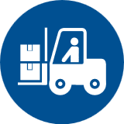 Start-Work Checks | Working Around Mobile Equipment

Start Work Authority: Confirm below are in place and verified prior to starting work
Save Your Life Actions  All exposed person(s) performing work must confirm each action below |  |  |  | Person(s) Performing Work (initial) | Start-Work  Verifier  (initial) | 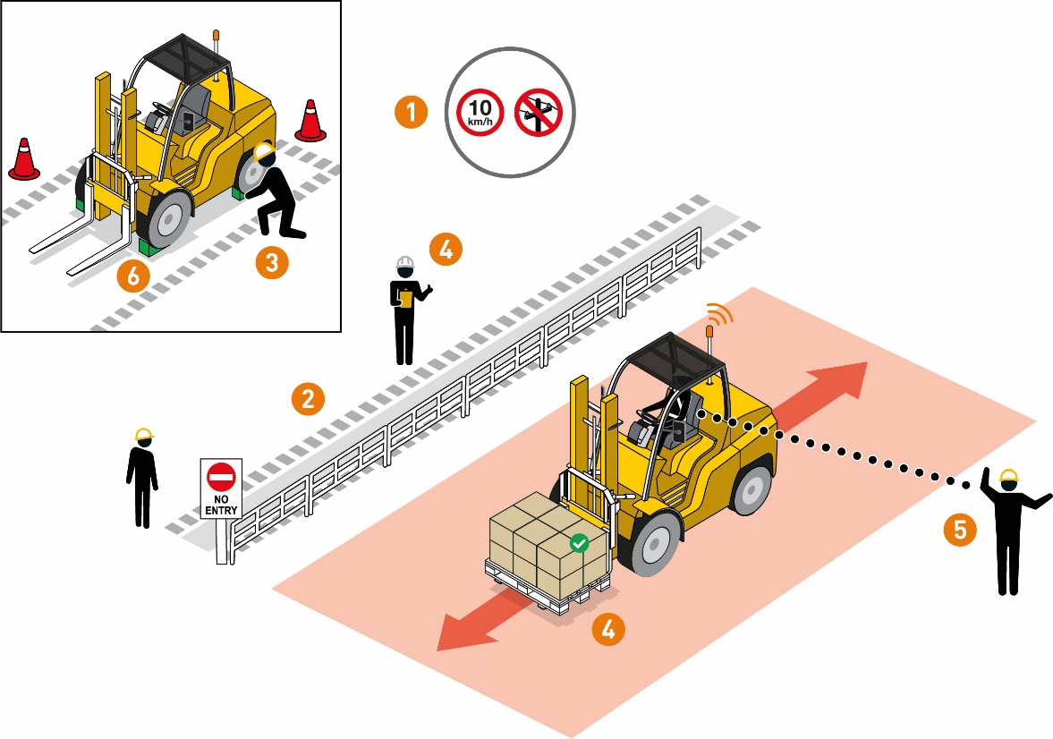
I have confirmed:
1 | Mobile equipment parking areas and travel paths have been identified for the work site.
2 | Controls/safeguards are in place to keep pedestrians away from mobile equipment.
3 | Mobile equipment has been inspected.
4 | Equipment/load stability and potential for unplanned movement has been assessed.
5 | Controls/safeguards are in place to prevent impact with workers or objects.
6 | Controls are in place to prevent unintentional movement of mobile equipment and/or loads.

Stop and seek help if any of the above controls/safeguards are not in place
Role |  | Printed Name | Date
Start -Work Verifier

Save Your Life Actions | Working Around Mobile Equipment

Start Work Authority: I will not start work until I confirm…
Actions |  | How to (examples)
1 | Mobile equipment parking areas and travel paths have been identified for the work site. | • Mobile equipment has:  • designated parking area  • lighting is in place for night or low visibility prior to movement  • side and overhead clearance  • clearly posted and enforced speed restrictions
2 | Controls/safeguards are in place to keep pedestrians away from mobile equipment. | • Interaction between workers and mobile equipment is eliminated or minimized by:  • dedicated walkways/paths  • signage and barriers are in place to separate pedestrians from mobile equipment paths  • clearly define pedestrian crossing points
3 | Mobile equipment has been inspected. | • Pre-mobilization and periodic site equipment inspections are conducted and have checked for:  • signs of leaks  • damage  • brake functionality test  • Safety devices such as alarms, seats, back -up alarm are functioning.  • Defective equipment(s) are tagged and removed from operation
4 | Equipment/load stability and potential for unplanned movement has been assessed. | • Equipment, loads and ground surface have been assessed for stability, taking into account:  • load securing  • workplace conditions/travel path  • equipment capacity
5 | Controls are in place to prevent collisions. | • Mobile equipment is free from hazards prior to movement (e.g. perform a 360 walk around)  • Options to reversing have been assessed prior to reverse operation of equipment.  • Audible warnings are working on equipment for reverse operations.  • Flagger/spotter/ground guide is positioned out of the line of fire and is able to monitor reversing operations.  • Use a clear system of signalling agreed with the operator  before starting (e.g., hand signals and/or radio communications and emergency stop signals).  • Physical barriers are in place in accordance with the activity plan.  • Define safe distance from mobile equipment and control access to the area  Note: Before using a Flagger/spotter/ground guide, assess the risk that they will be exposed to. Take precautions to protect them. Only use properly trained personnel or technology alternatives (e.g. cameras/proximity sensors).
6 | Controls are in place to prevent unintentional movement of mobile equipment and/or loads. | • Equipment is located on flat ground where possible  • Equipment wheels are chocked when there is potential for movement.  • Booms, attachments and accessories are lowered or secured to prevent energy release/movement.  • Key is removed when the equipment is not in operation

